SA DAIRY INDUSTRY FUND
“EXPRESSION OF INTEREST”
APPLICATION FORM
Project Year 2017

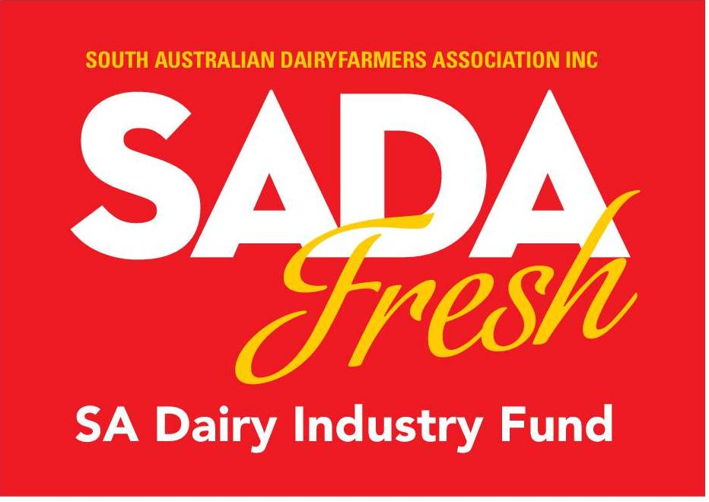

1. Project Title (Brief)

2. Project Contact Information

Applicant

ABN

ACN

Postal Address

Street Address

Primary Project

Contact Name

Position

Address for correspondence (if different form above)

Telephone

Mobile

Fax

Email Address

Secondary Project Contact Name

Position

Address for correspondence (if different form above)

Telephone (w)

Mobile

Fax

Email Address

3. Project Details (Expand space as required)
Project Title
Start Date
Completion Date
Project Location/s
Total Project Cost  (GST exclusive) | $
Amount requested from SA Dairy Industry Fund | $
Co-funder Contributions  (please list contributing organisation & $ amount) | $ | $ | $
Project Summary
(the information provided here will be used to promote the project) (no more than 100 Words)
Project objectives/aims?
(please describe)
(no more than 100 Words)

Project methodology
(please describe)

How will the project benefit South Australia’s dairy industry?

How does the project link with other industry initiatives?
(is it strategic and integrated?)

4. Organisation Information (Expand space as required)
What are the main activities of your organisation?
(please describe)

How long has your organisation been in operation?

Demonstrate how your organisation has the capacity to complete the project successfully and on time and on budget.

Please provide details of recent project experience (i.e. last 2 – 4 years) including: Project Title, Brief Project Description, Time Frame, Funding Source and Cost of Project.

5. Applicant Declaration

I certify that the information supplied in this assessment is a true and fair statement.

Position:
Organisation:
Signed:
Name:
Date: | / /

For further information, including Application Guidelines visit www.sadafresh.com.au or contact:
John Elferink
Executive Officer
SA Dairy Industry Fund
Email: dairyindustryfund@sada.asn.au
Mobile: 0418406400

Please forward all completed applications to:
SA Dairy Industry Fund
Unit 5, 780 South Road
GLANDORE SA 5037
or
Email: dairyindustryfund@sada.asn.au

